**Project Name:** JSONBinTestProject

**Feature File:** JSONBinSample.feature (refer below screenshot of the file)

Description: In feature file 7 scenarios are created with Scenario Outline (to show data driven) and

Scenario methodology.

*@RegressionTest* tag is used so that it can used in Junit test runner file.

*Then* step is reuse in all the scenarios.

|  |  |  |
| --- | --- | --- |
| **Scenario** | **Method Type** | **Description** |
| 1 | GET | This scenario is for GET request call for specific BinID and it will verify the return code with given text value. |
| 2 | POST | This scenario is for POST request call where it will create Bin with hard coded text but with unique Bin-Name based on date and time. |
| 3 | POST | This scenario is for POST request call where it will create Bin with provided text but with unique Bin-Name based on date and time. |
| 4 | PUT | This scenario is for PUT request call where it will update the sample value for provide BinID. |
| 5 | DELETE | This scenario is for Delete request call where it will delete the provide BinID. |

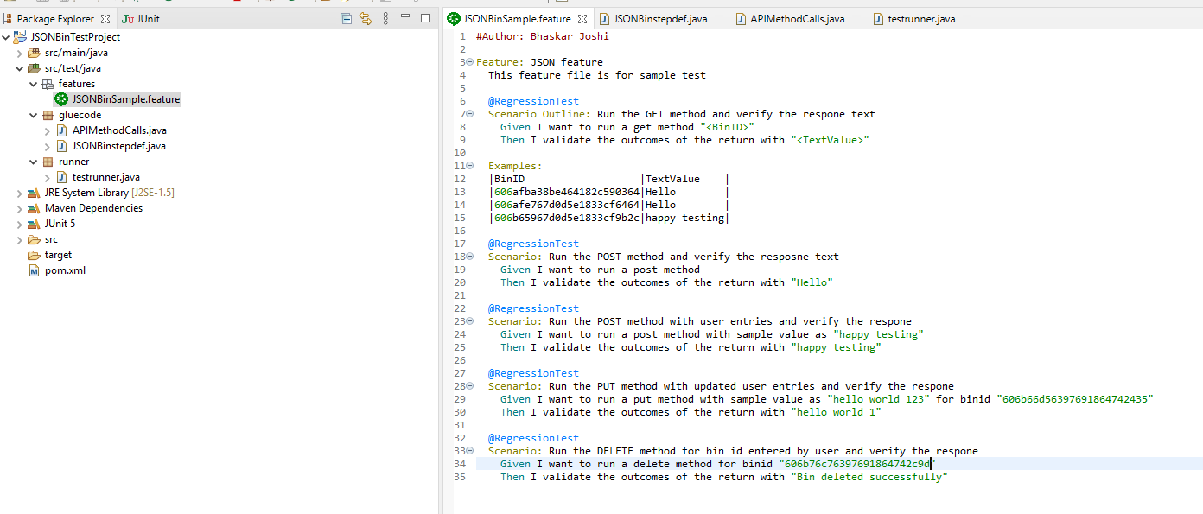

**Step Definition File:** JSONBinstepdef.java (refer below screenshot of the file)

Description: This is a step definition file.

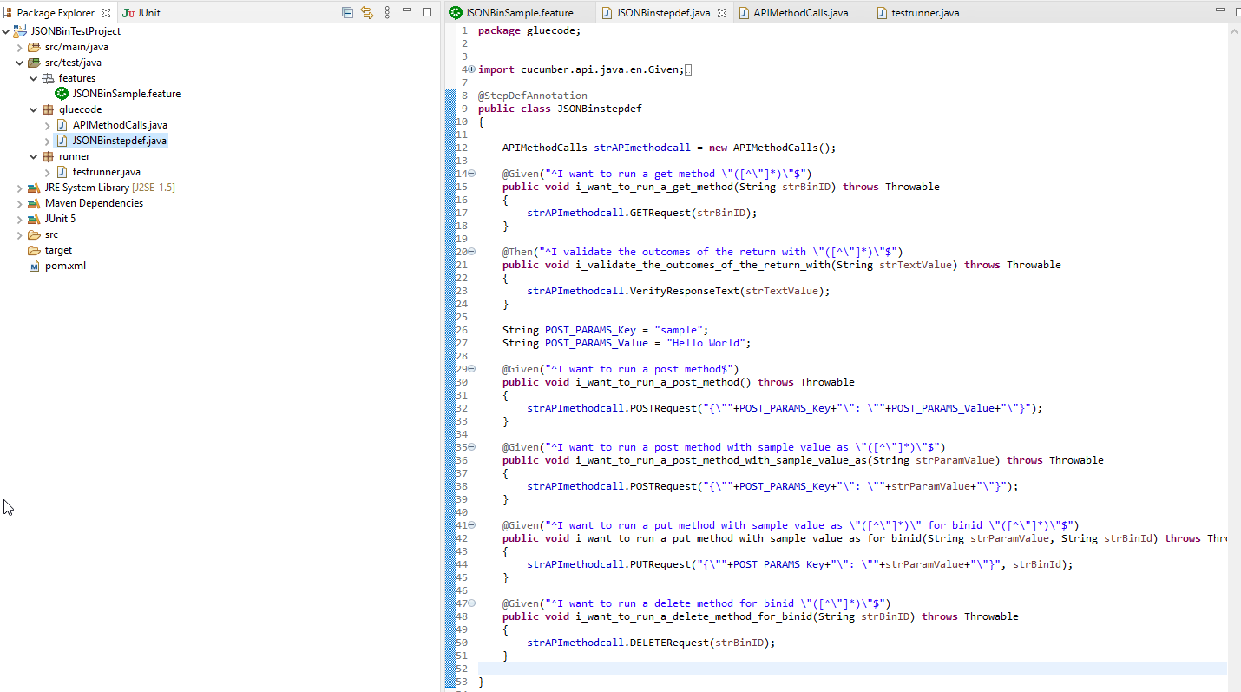

**Reusable / Generic API Call Functions File:** APIMethodCalls.java

Description: This is a java file which contains API call methods and generic functions which can be use across the project.

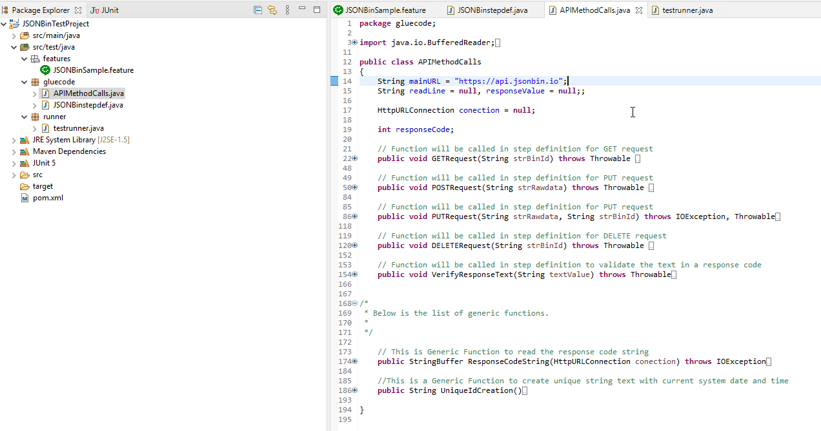

**Junit Runner File:** testrunner.java

Description: This is a Junit test runner file to fun the feature file. User can run the specific scenarios based on tags given for the scenarios.

If user want to use different tags then it can be extended. Eg: tags = {“@tag1”,”@tag2”}

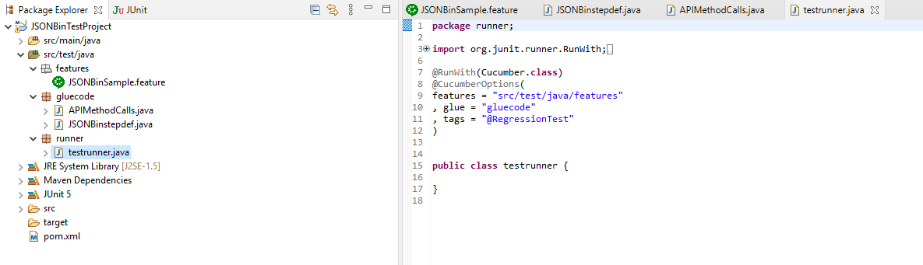

**Execution Results:**

* Run from Cucumber Feature file

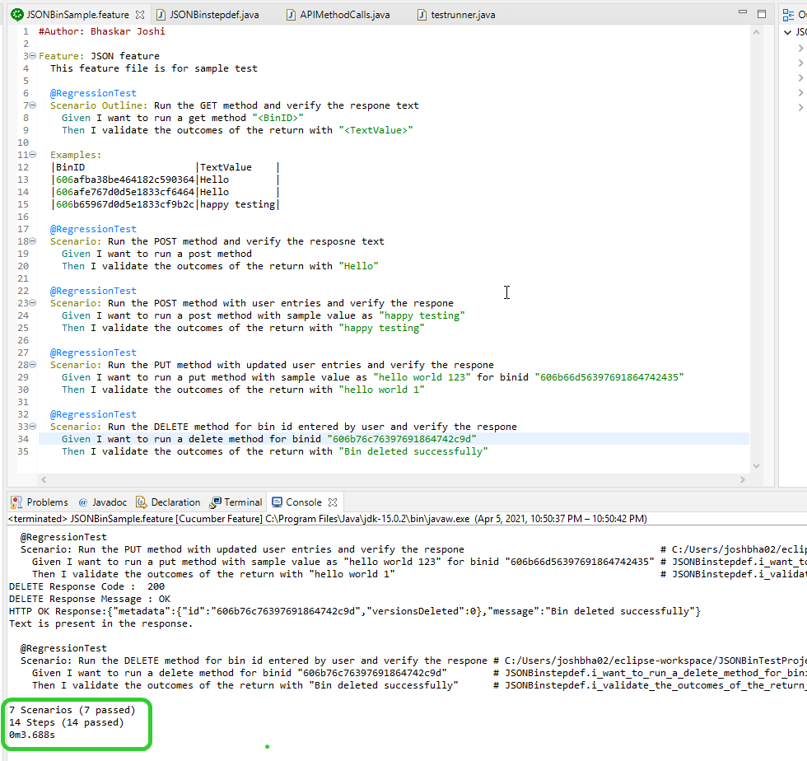

* Run as Junit Test Runner file based on tags
  + First execution

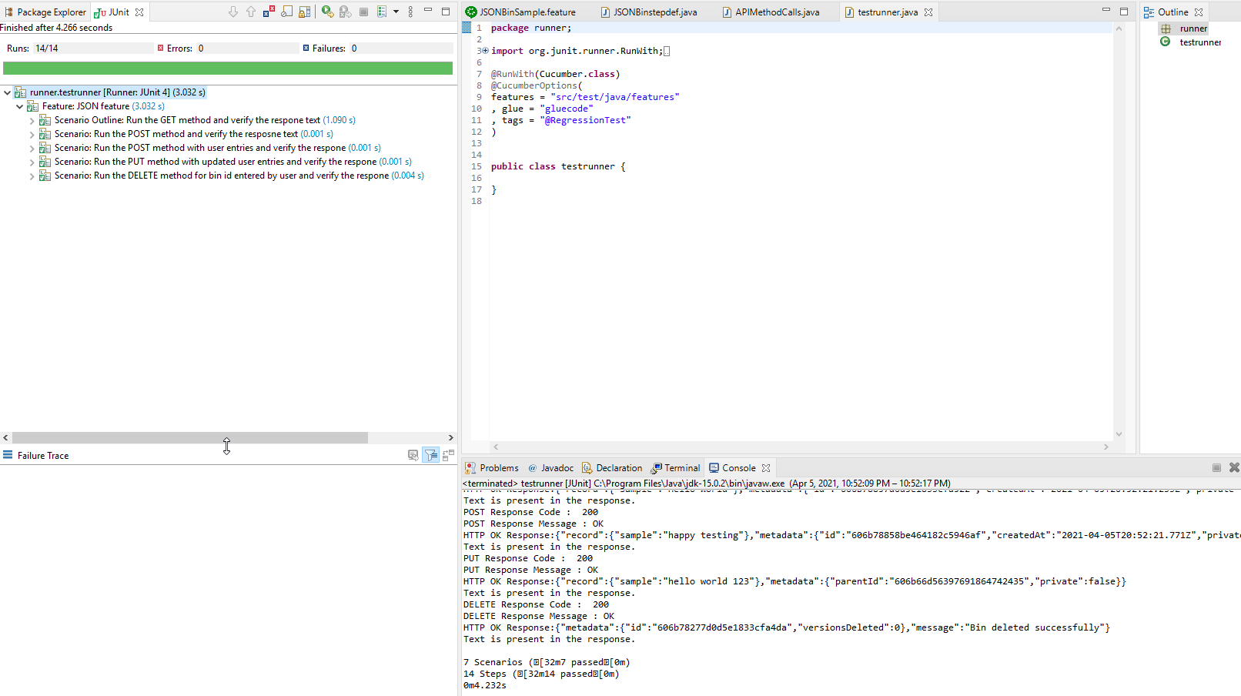

* + Second run to see the DELETE will fail because BINID is already deleted

